**The University Of Azad Jammu & Kashmir,Muzaffarabad**

Name: Muqaddas Kiani

Roll NO: 2024-SE-23

Course Code: CS-1204

Submission Date:13thMay ,2025

Instructor Name: Engr. Awais Rathore

Course Title: Object Oriented Programming

DEPARTMENT OF SOFTWARE ENGINEERING

**~:UML Class Diagram:~**

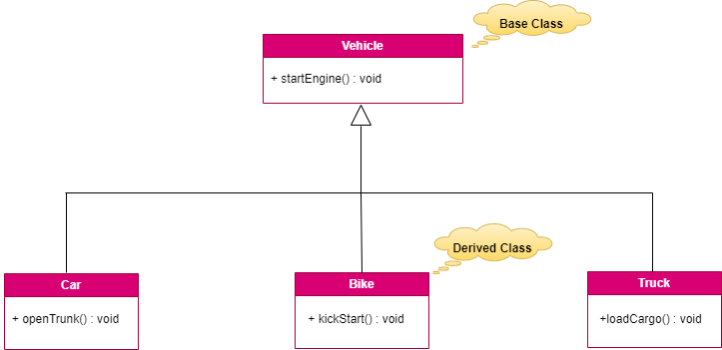

**Hierarchical Inheritance:**

* when multiple derived classes inherit from a single base class.
* It has one parent class and many child classes.

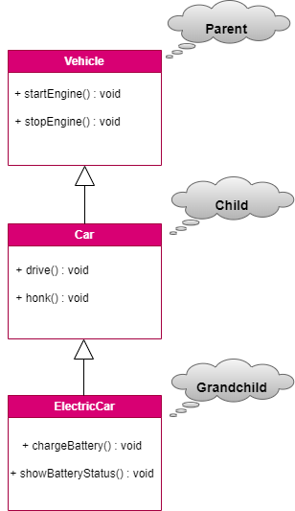

**Multilevel Inheritance:**

* Multilevel inheritance involves a class derived from a class that is already derived from another class.
* parent–child grandchild hierarchy.

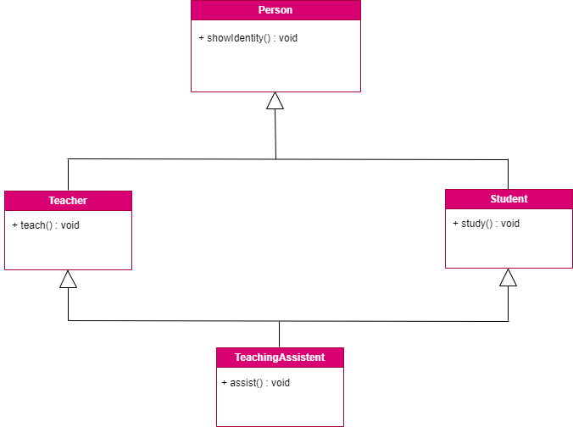

**Hybrid Inheritance:**

* Hybrid inheritance is a combination of more than one type of inheritance.
* In this type, compiler is confused which path can be use.
* Also known as Diamond Problem

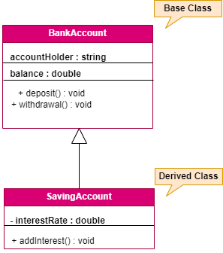

**Single Inheritance:**

* Single inheritance allows a derived class to inherit from one base class.
* It is simplest and easy to understand.